**ServiceNow Laptop Request Catalog Item**

Project Documentation

Team ID: ***NM2025TMID18318***

Team Members:

Team Leader: Lavanya P R

Team members:

Sadhana Devi R

Keerthika S

Dashwini R

Problem statement:

The laptop request process was manual and fragmented, causing delays, missing details, and poor user experience.

Objective:

To automate and standardize laptop requests using ServiceNow with dynamic forms and seamless deployment.

Skills:

ServiceNow Development, Automation & Workflow Design, Problem-Solving, Testing & Validation, Deployment & Migration ,Documentation & Project Management.

# Table of Contents

1. **ServiceNow Introduction**
2. **Project Introduction**  
   2.1 Project Overview
3. **Business Case & Requirements**  
   3.1 Problem Statement  
   3.2 Project Goals & Objectives  
   3.3 Success Metrics
4. **Project Scope**  
   4.1 In-Scope  
   4.2 Out-of-Scope  
   4.3 Assumptions & Constraints
5. **System Design & Architecture**  
   5.1 Process Workflow  
   5.2 Data Model (Variables)  
   5.3 UI/UX Wireframes
6. **Applications and Uses**
7. **Advantages**  
   7.1 Operational Efficiency  
   7.2 Improved User Experience  
   7.3 Cost Savings & Scalability
8. **Development - Step-by-Step Implementation**  
   8.1 Creating the Local Update Set (Milestone 1)  
   8.2 Building the Catalog Item (Milestone 2)  
   8.3 Add Variables  
   8.4 Create a Catalog UI Policy (Milestone 3)  
   8.5 Create UI Action (Milestone 4)  
   8.6 Export and Deployment (Milestone 5 & 6)  
   - 8.6.1 Export the Update Set  
   - 8.6.2 Import to a Target Instance
9. **Testing and Validation (Milestone 7)**
10. **Internal Testing Participants (ITPs)**  
    10.1 ITPs Plan  
    10.2 ITPs Results Summary
11. **Roles and Responsibilities**
12. **Troubleshooting & Known Issues**
13. **Future Enhancements**
14. **Glossary of Terms**
15. **Conclusion**

# **1.ServiceNow Introduction**

ServiceNow is a cloud-based platform that provides digital workflows to automate IT, HR, facilities, and business processes. It offers a centralized service catalog, ticketing system, and workflow automation tools that improve efficiency, reduce manual work, and enhance user experience across organizations.

# 2.Project Intoduction

Our project, **Laptop Request Catalog Item**, is designed in ServiceNow to replace the manual laptop request process with an automated and user-friendly system. It enables employees to request laptops through a standardized catalog form, ensures accurate data collection with dynamic fields, and improves transparency, efficiency, and overall user satisfaction.

## 2.1 Project Overview

The Laptop Request Catalog Item project uses ServiceNow's Service Catalog to replace manual, error-prone workflows with a dynamic and user-friendly interface. It streamlines the process of requesting laptops within an organization, leading to enhanced operational efficiency and a better employee experience.

# 3.Business Case & Requirements

## 3.1 Problem Statement

The process for employees to request laptops was fragmented, often occurring via email or informal requests. This led to:  
  
- Incomplete information (missing justification, model numbers, accessory details).  
- Difficulties in tracking and reporting on requests.  
- Increased processing time and manual follow-up by IT staff.  
- Poor user experience and lack of transparency for the requester.

## 3.2 Project Goals & Objectives

Primary Goal: To create a single, standardized, and automated portal for all laptop requests.  
  
Objective 1: Develop a Service Catalog item with necessary data fields.  
Objective 2: Implement conditional logic to dynamically request accessory details only when needed.  
Objective 3: Ensure the solution is portable from development to production instances.  
Objective 4: Validate functionality through rigorous User Acceptance Testing (UAT).

## 3.3 Success Metrics

- Reduction in ticket processing time by 25%.  
- Elimination of manual follow-up emails for missing information.

- Beneficial to analyses cost cuttings to company.

- Beneficial to keep order spare parts.  
- Positive feedback from internal testing participants (ITPs).

# 4. Project Scope

## 4.1 In-Scope

- Service Catalog item creation within the 'Hardware' category.  
- Configuration of four specific variables.  
- One (1) UI Policy to control the visibility of the 'Accessories Details' field.  
- One (1) UI Action for form reset (client-side script).  
- Development in a sub-production instance.  
- Deployment via Update Sets to a target instance for UAT.

## 4.2 Out-of-Scope

- Back-end approval workflows.  
- Integration with procurement or asset management systems.  
- Reporting dashboards.  
- Email notifications.  
- Mobile-specific development.

## 4.3 Assumptions & Constraints

**Assumptions:**  
- Users have basic access to the ServiceNow Service Catalog.  
  
**Constraints:**  
- Project must use existing ServiceNow licensing; no custom plugins or outside software permitted.  
- Timeline is fixed at two weeks.

# 5. System Design & Architecture

## 5.1 Process Workflow:

- User navigates to Service Catalog -> Hardware.

- User clicks "Laptop Request."

- User fills in required fields (Model, Justification).

- If user checks "Additional Accessories," a new field appears and is required.

- -User submits the form.

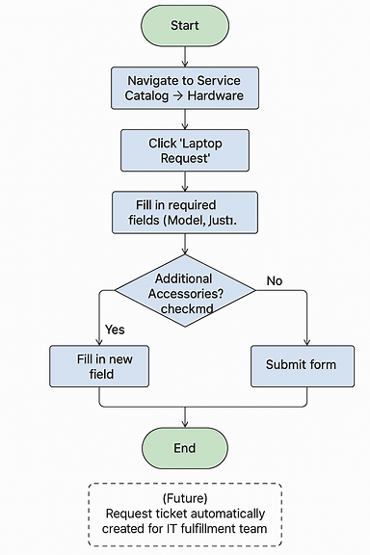

A detailed flowchart using shapes (Start/End, Process, Decision) illustrating the user's path and the UI Policy decision point.

## 5.2 Data Model (Variables):

A detailed table is presented here (as in the previous response) listing each variable's Label, Type, Name, Order, and Description.

## 5.3 UI/UX Wireframes:

**Wireframe 1:** Initial form view, showing Laptop Model, Justification, and the Additional Accessories checkbox. The Accessories Details field is hidden.

**Wireframe 2:** Form view after the checkbox is clicked. The Accessories Details field is now visible and marked with a red asterisk (*) to indicate it is mandatory.

Create two UI/UX wireframe mockups for a laptop request form:

Wireframe 1: Initial form view showing fields for Laptop Model, Justification, and a checkbox labeled "Additional Accessories". The Accessories Details field is hidden.

Wireframe 2: Form view after the checkbox is clicked. The Accessories Details field is now visible and marked with a red asterisk (*) to indicate it is mandatory.

**Note:** These can be simple mockups created in PowerPoint or a free tool like draw.io.

# 6.Applications and Uses

The Service Catalog's functionality extends far beyond just requesting a laptop. It can be applied to a wide range of business functions to streamline service delivery and improve the user experience.

IT Services: Software installation requests, hardware support tickets, network access requests, and password resets.  
Human Resources (HR): Employee onboarding/offboarding, new hire equipment, benefits inquiries.  
Facilities Management: Requests for office supplies, maintenance, room reservations, or desk bookings.

# 7. Advantages

## Operational Efficiency:

**Automation:** Pre-defined workflows automate approvals and tasks, eliminating repetitive, manual work.  
**Reduced Errors:** Standardized forms ensure accurate data collection, reducing human error.

## Improved User Experience:

**Self-Service Convenience:** User-friendly interface for easy browsing and ordering.  
**Increased Visibility:** Users track status of requests in real-time, reducing follow-ups.

## Cost Savings & Scalability:

**Lower Costs:** Automation reduces operational costs.  
Scalability: Extendable beyond IT to HR and Facilities.

# 8. Development - Step-by-Step Implementation

This section provides the detailed, step-by-step instructions from your original document, but is enhanced with "Why" explanations and larger, annotated screenshots.

## 8.1 Creating the Local Update Set(MILESTONE 1)

**Step:** Navigate to All > System Update Sets > Local Update Sets > New.

**Action:** Create update set "Laptop Request Project".

**Why:** This creates a container to track all subsequent changes, enabling clean migration to other instances.

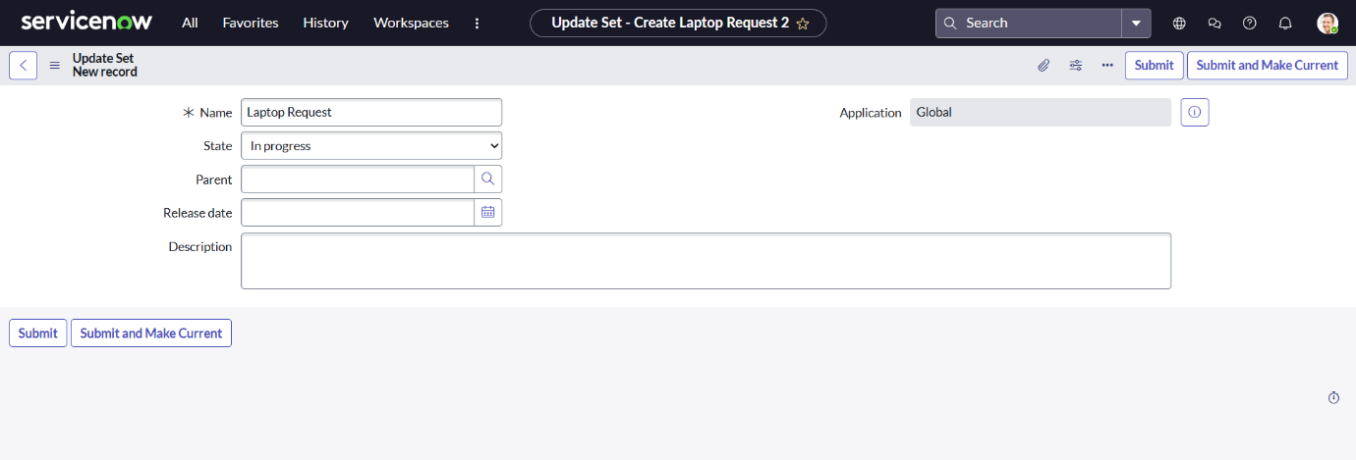

## 8.2 Building the Catalog Item(MILESTONE 2)

**Step:** Navigate to All > Service Catalog > Catalog Definitions > Maintain Items > New.

**Action:** Populate Name, Catalog, Category, and Description.

**Why:** This defines the core item that users will see and interact with.

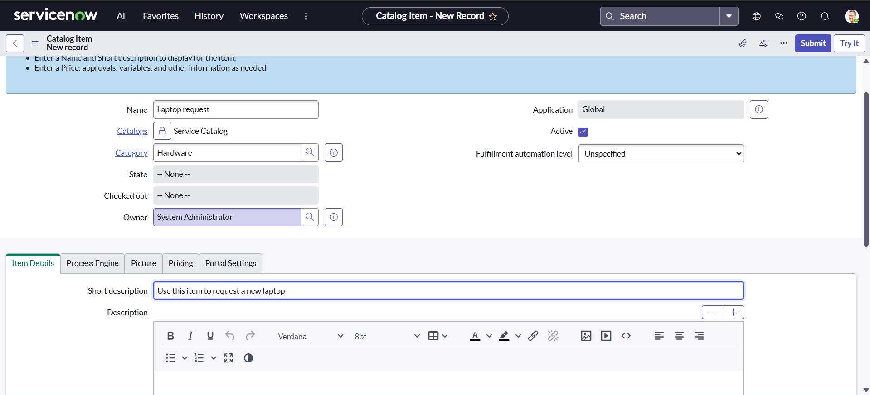

## **8.3 Add Variables**

#### **Step:** Navigate to Maintain Items > Select **Laptop Request** > Scroll to **Variables** tab > Click **New**.

#### **Action:** Create the following variables with appropriate configurations:

|  |  |  |  |  |  |
| --- | --- | --- | --- | --- | --- |
| **Label** | **Type** | **Name** | **Order** | **Mandatory** | **Description** |
| Laptop Model | Single Line Text | laptop_model | 100 | No | Captures the specific model of laptop requested. |
| Justification | Multi Line Text | justification | 200 | Yes | Explains the reason for the laptop request. |
| Additional Accessories | Checkbox | additional_accessories | 300 | No | Allows user to indicate if extra accessories are needed. |
| Accessories Details | Multi Line Text | accessories_details | 400 | Conditional | Becomes mandatory if "Additional Accessories" is checked. Captures details. |

#### **Why:** These variables define the user input fields for the **Laptop Request** form. They ensure structured data collection, support dynamic UI behavior, and enable future automation for IT fulfillment.

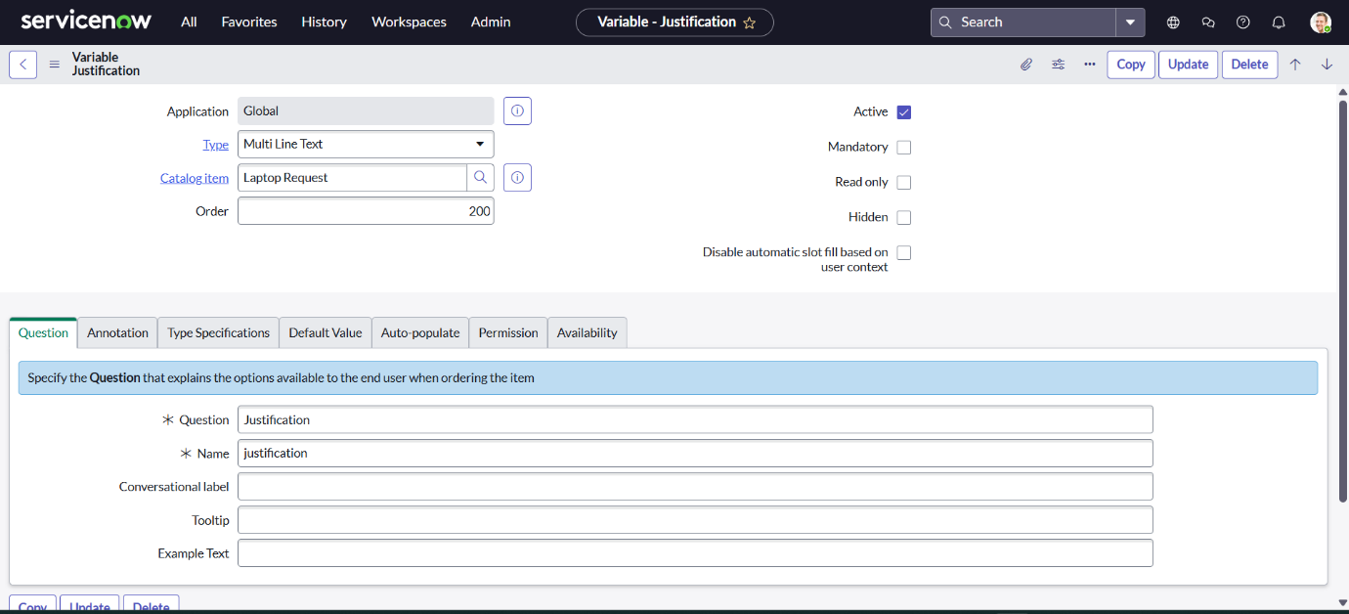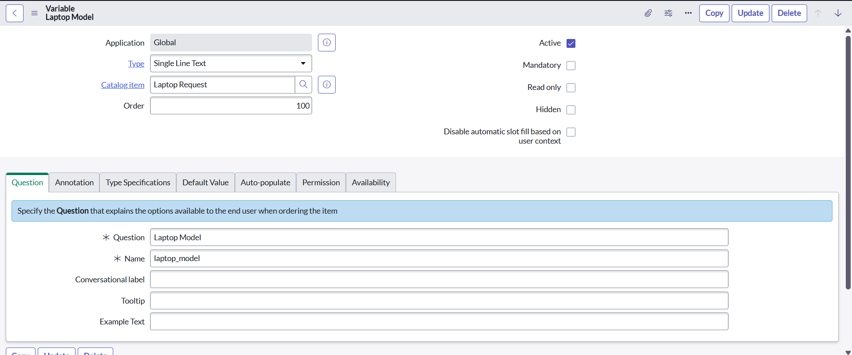

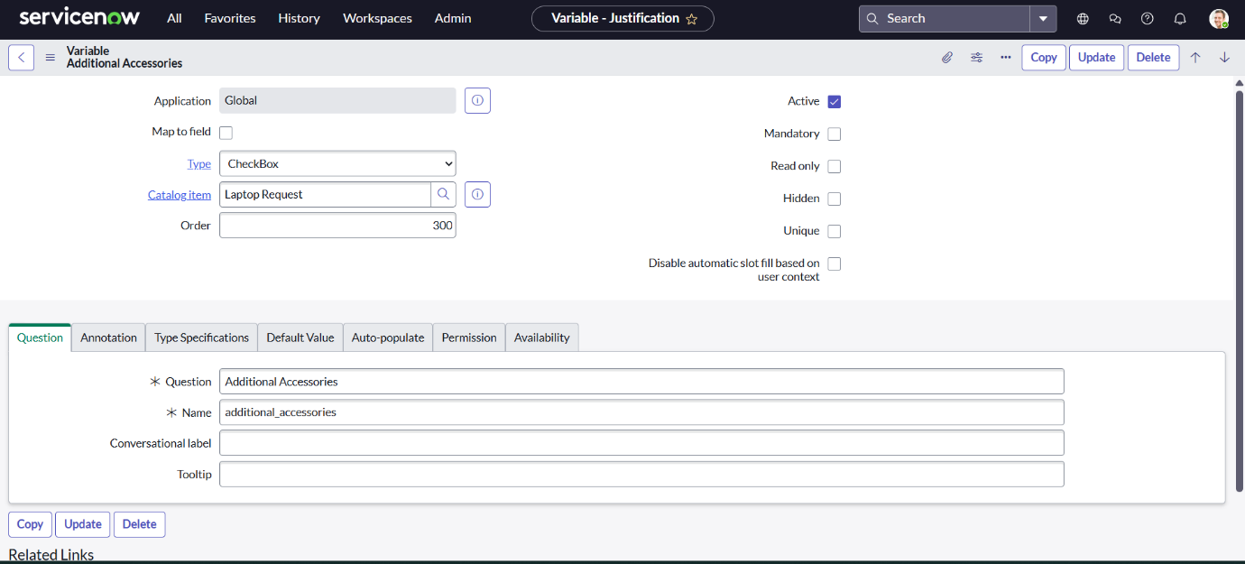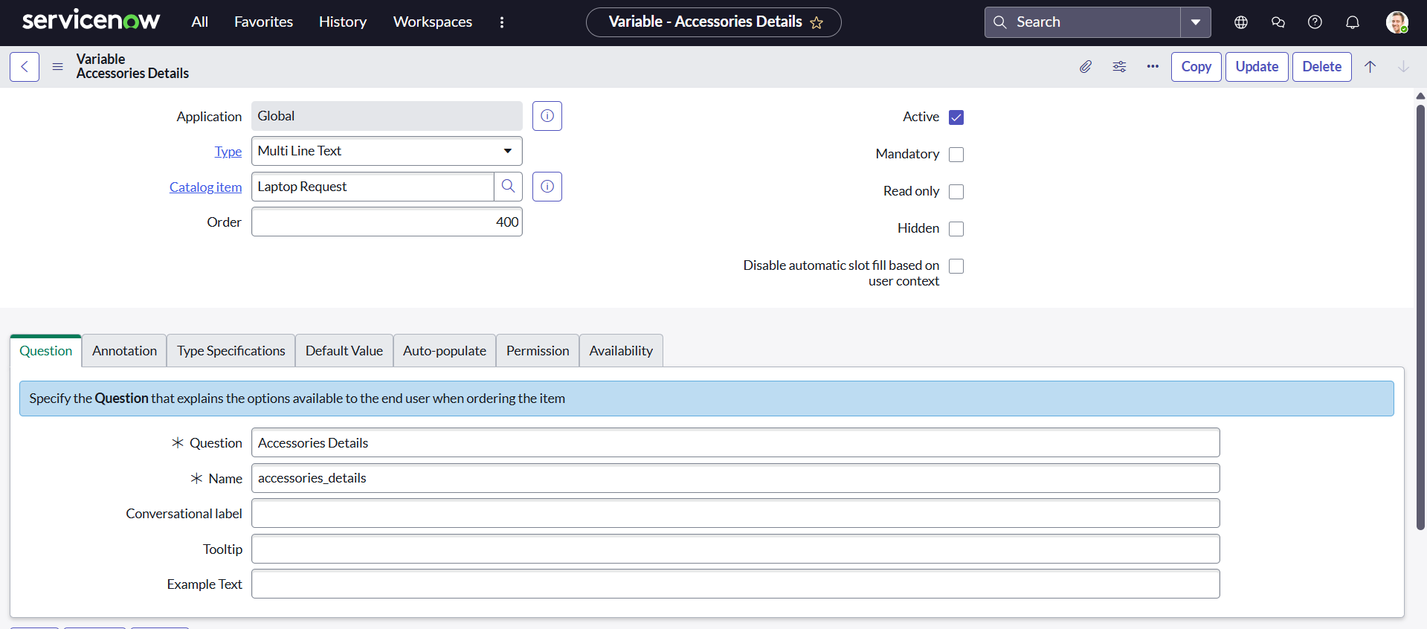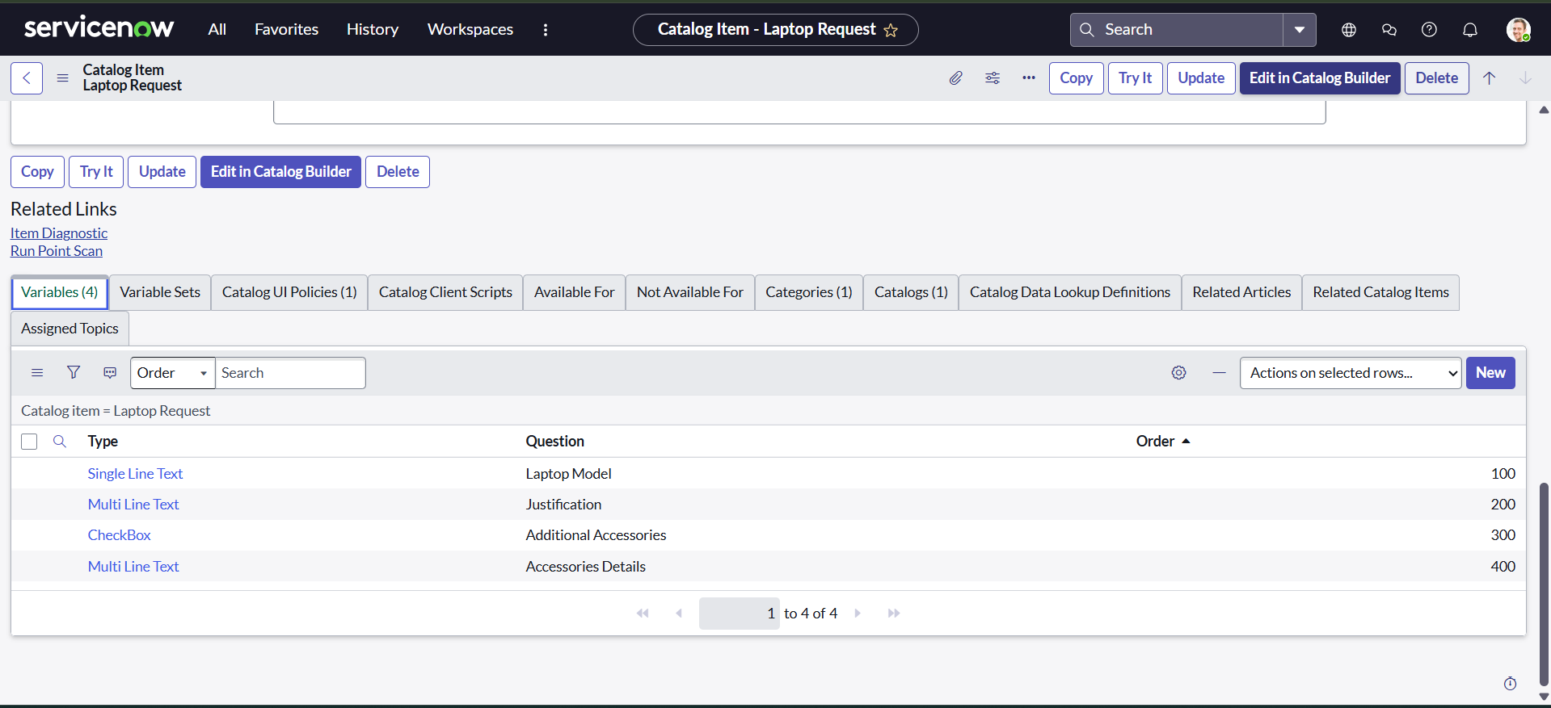

## **8.4 Create a Catalog UI Policy(MILESTONE 3)**

#### **Step:** Navigate to *Service Catalog > Catalog Definitions > Maintain Items* > Open **Laptop Request** > Scroll to **Catalog UI Policies** tab > Click **New**.

#### **Action:** Configure the UI Policy with the following details:

* **Applies to:** A Catalog Item
* **Catalog Item:** Laptop Request
* **Condition:** additional_accessories **is** true
* **Reverse if false:** Checked
* **Active:** Checked
* **Short Description:** Show Accessories Details when Additional Accessories is selected

Then, add a **UI Policy Action**:

|  |  |
| --- | --- |
| **Field** | **Value** |
| Variable | accessories_details |
| Visible | True |
| Mandatory | True |
| Read-only | False |

#### **Why:** This UI Policy ensures that the **Accessories Details** field only appears when the user selects **Additional Accessories**, creating a cleaner, more intuitive form experience and reducing unnecessary input fields

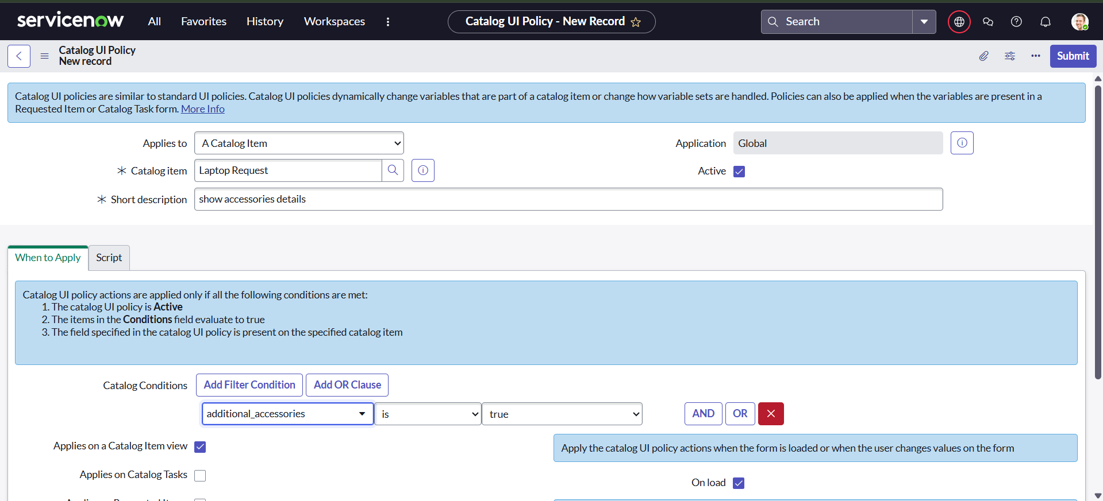

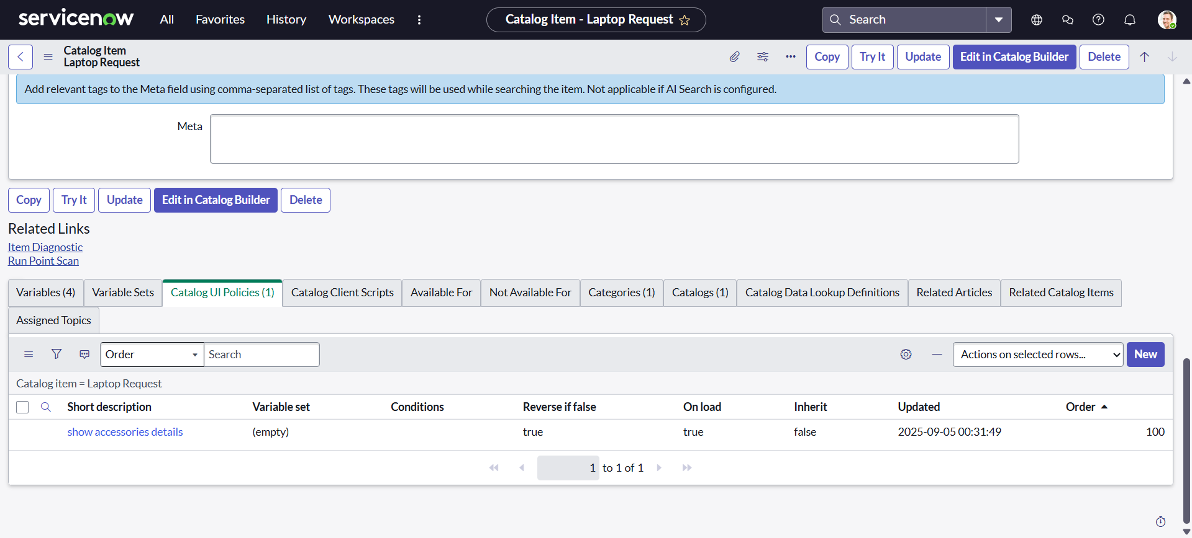

## **8.5. Create UI Action(MILESTONE 4)**

#### **Step:** Navigate to System Definition > UI Actions > Click **New**.

#### **Action:**Configure the UI Action with the following details:

|  |  |
| --- | --- |
| **Field** | **Value** |
| Table | shopping cart(sc_cart) |
| Name | Reset Form |
| Action name | Reset Form |
| Order | 100 |
| Client | Checked |
| Active | Checked |
| Script | See below |

**Script:**

|  |
| --- |
| **Javascript**  **function resetForm() {**  **g_form.clearForm(); // Clears all fields in the form**  **alert("The form has been reset.");**  **}** |

#### **Why:** This UI Action provides users with a quick way to clear all fields in the shopping cart form, improving usability and allowing them to start over without manually deleting each entry.

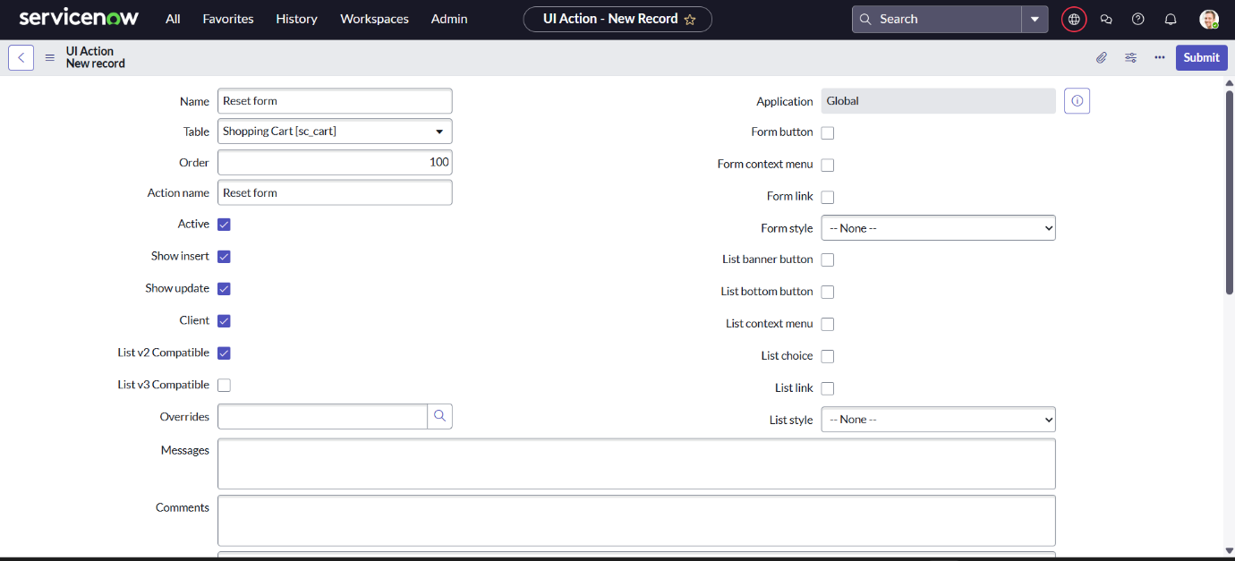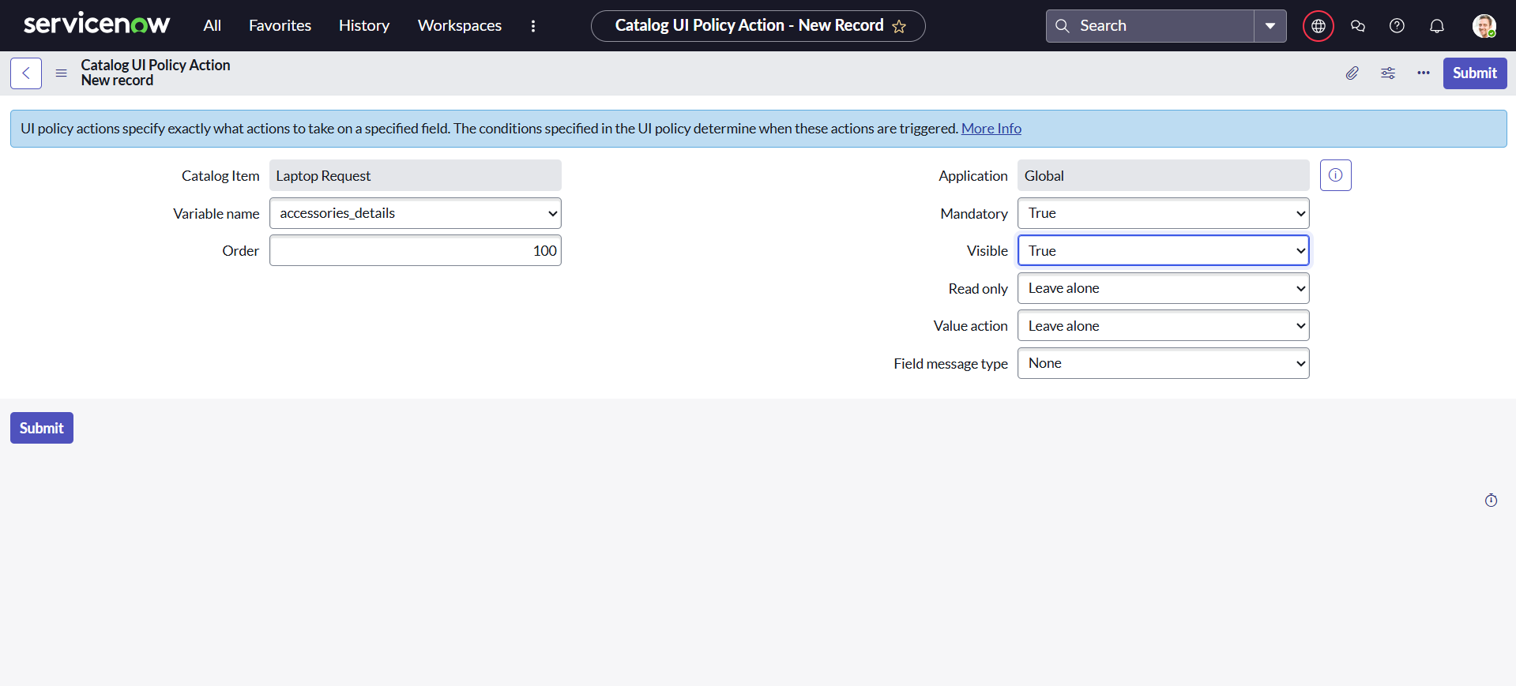

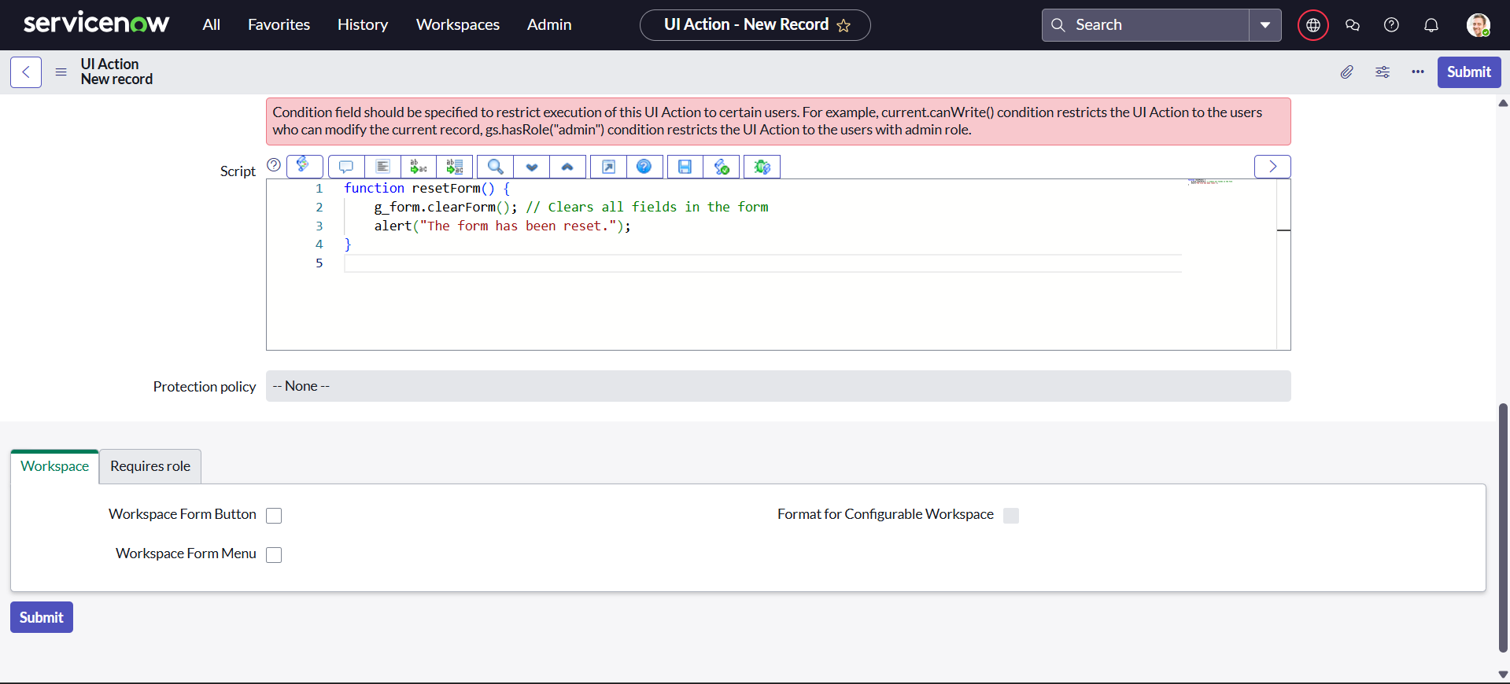

# 8.6 Export and Deployment

## **8.6.1 Export the Update Set(MILESTONE 5)**

#### **Step:** Navigate to *System Update Sets > Local Update Sets* > Open the update set named **Laptop Request**.

#### **Action:** Set the **State** to Complete. Click **Export to XML** from the top-right menu.

#### **Why:** Exporting the update set as an XML file allows you to migrate all related configuration changes—such as catalog items, variables, UI policies, and UI actions—from one ServiceNow instance to another. This ensures consistency across environments and supports deployment best practices.

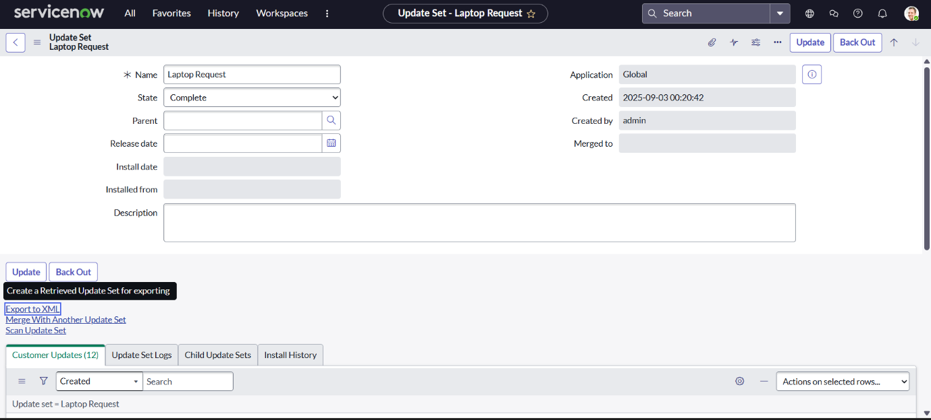

## **8.6.2 Import to a Target Instance(MILESTONE 6)**

#### **Step:** Navigate to System Update Sets > Retrieved Update Sets on the **target instance**.

#### **Action:**

* Click **Import Update Set from XML**.
* Upload the exported XML file (e.g., Laptop Request.xml).
* Once imported, click **Preview** to validate changes.
* If no errors are found, click **Commit** to apply the update set.

#### **Why:** This step transfers all configuration changes—catalog items, variables, UI policies, and UI actions—from the source instance to the target environment. Previewing ensures integrity, and committing finalizes deployment for production or testing.

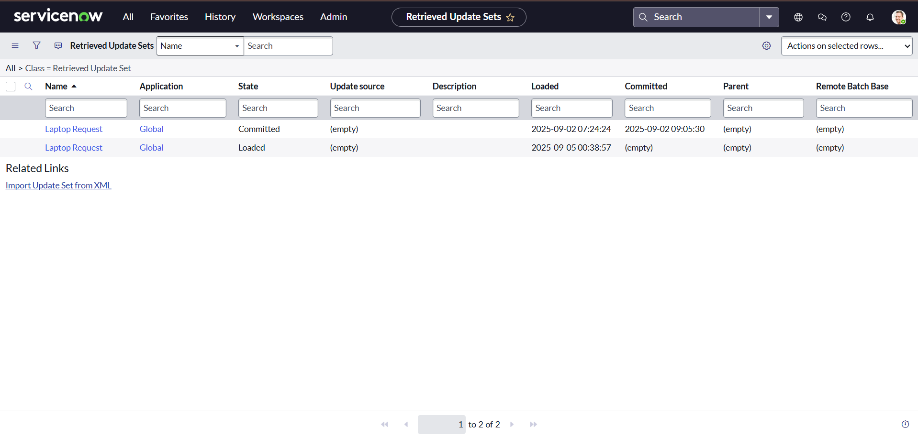

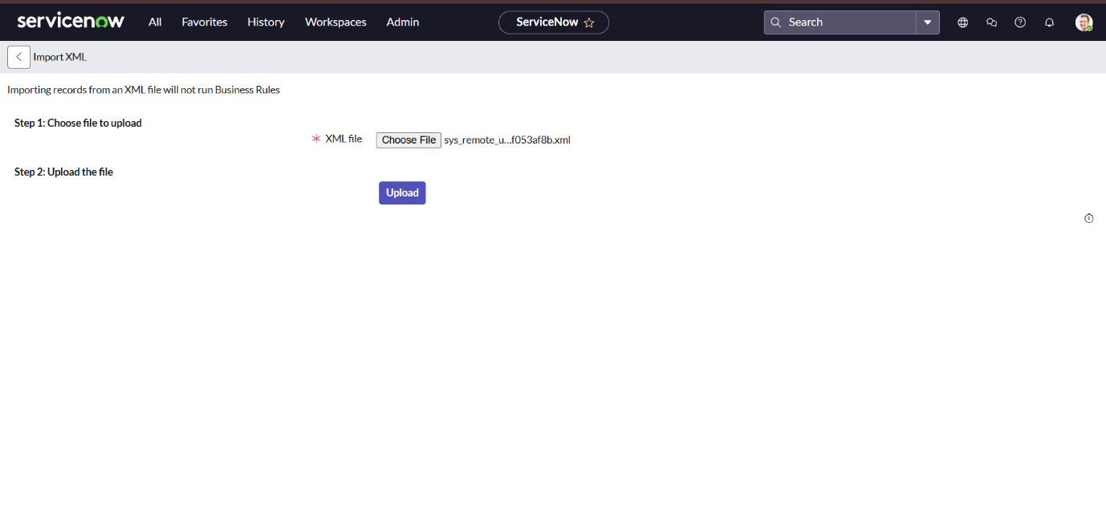

# **9.Testing and Validation(MILESTONE 7)**

#### **Step:** Navigate to **Service Catalog > Hardware Category**, then open the **Laptop Request** catalog item.

#### **Test Objective:** Verify the dynamic behavior of the **Accessories Details** field based on user interaction.

#### **Expected Behavior:**

* 🟢 **Initial State:**
  + Accessories Details field is **hidden** when the form loads.
* ✅ **Trigger Condition:**
  + When the checkbox **Additional Accessories** is selected:
    - Accessories Details field becomes **visible**.
    - Field becomes **mandatory** for submission.

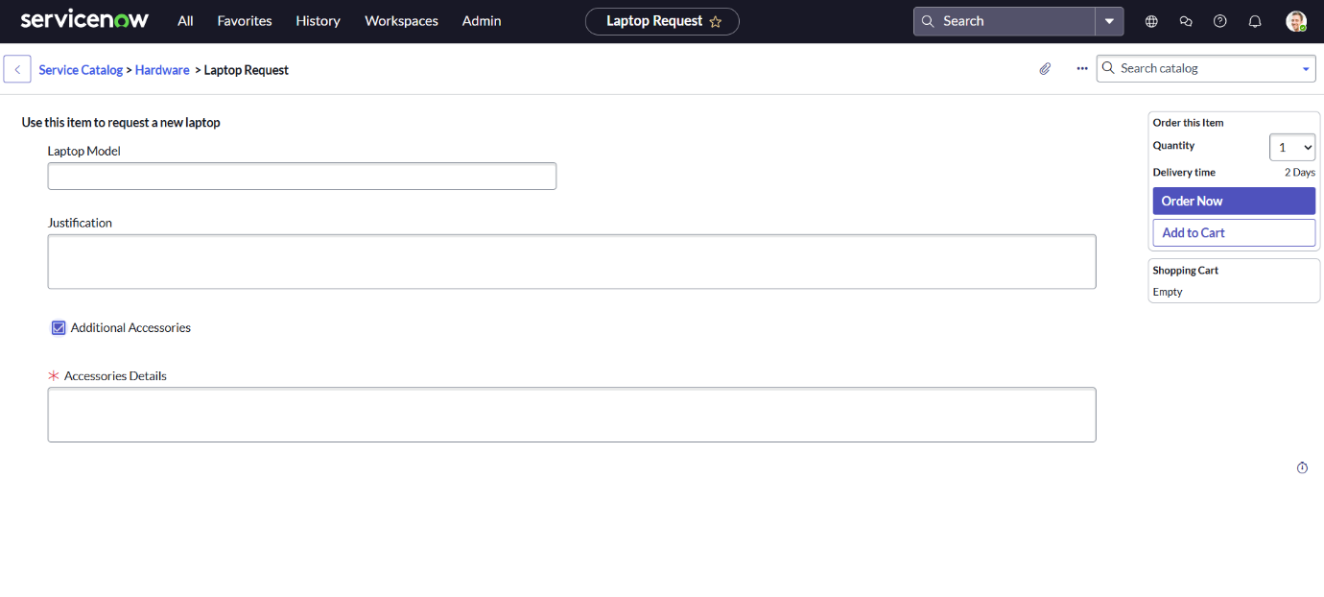

# 10. Internal Testing Participants (IPTs)

## 10.1 IPTs Plan

**Testers:** A group of 5 end-users from the IT, Finance, and Marketing departments.

**Test Instance:** IPTs environment (Target instance from section 7.6.2).

**Test Scenarios:**

Submit a laptop request without accessories. Verify the form submits successfully and a request ticket is created.

Submit a laptop request with accessories. Verify the "Accessories Details" field appears and is mandatory. Verify the form submits successfully.

Use the "Reset Form" UI Action and verify all fields are cleared.

Verify that all configured variables (Laptop Model, Justification, etc.) are correctly captured in the resulting ticket.

Feedback Mechanism: Testers will provide feedback via a Microsoft Forms survey, rating usability and noting any bugs or suggestion

## 10.2 ITPs Results Summary

**Participation:** 5 out of 5 testers completed the scenarios.

**Success Rate:** 100% of testers successfully completed all scenarios.

**Feedback:** Users found the form intuitive. One suggestion was to add a dropdown list for common Laptop Models. This has been noted for a future enhancement.

**Result:** IPTs was passed successfully, and the solution is ready for UAT production deployment.

# 11. Roles and Responsibilities

|  |  |
| --- | --- |
| **Role** | **Responsibilities** |
| ServiceNow Admin | Creating the update set, deploying the update set to target instances, overseeing the technical implementation. |
| Developer | Configuring the Catalog Item, Variables, UI Policy, and UI Action. |
| Tester | Executing the test scenarios outlined in Section 8 and Section 9.1. |
| Project Lead | Managing the timeline, coordinating UAT, and compiling documentation. |

# 12. Troubleshooting & Known Issues

|  |  |
| --- | --- |
| **Issue** | **Solution / Workaround** |
| The "Accessories Details" field did not become visible when the checkbox was clicked. | Verified the UI Policy condition (additional_accessories IS true) and ensured the "Reverse if false" checkbox was selected. This resolved the issue. |
| The "Reset Form" button did not clear the Multi-Line Text fields. | Confirmed the use of g_form.clearForm() which is a reliable client-side API to reset all variables on a form. |
| The update set preview showed conflicts with an existing system field. | The conflicting field was not in use. It was safely overridden by committing the update set. |

# 13. Future Enhancements

The following features were identified as valuable additions but were considered out-of-scope for this initial phase:

**Integration with Asset Management:** Automatically generate a Configuration Item (CI) upon ticket approval to pre-populate the asset database.

**Approval Workflow:** Implement a multi-step approval process involving the requester's manager and IT leadership for budgetary and technical validation.

**Enhanced Reporting:** Develop a dashboard for IT management to analyze request volume, popular models, and fulfillment timelines.

# 14. Glossary of Terms

Service Catalog: A centralized portal where users can request services and goods, standardizing the intake process.

**Catalog Item:** A specific offering within the Service Catalog, in this case, the "Laptop Request."

**Variable:** A field on a catalog item form that collects information from the user (e.g., Laptop Model, Justification).

**UI Policy:** A business rule that dynamically controls the behavior (visibility, mandatoriness) of a form field based on user input.

**UI Action:** A configurable button or link that performs an action on a form, such as resetting fields.

**Update Set:** A container used in ServiceNow to group customizations for easy migration between instances (e.g., from Development to Production).

# 15. Conclusion

The Laptop Request Catalog Item project successfully transforms a manual process into an automated workflow using ServiceNow. It highlights dynamic forms, governance via update sets, and cross-instance deployment. This improves service delivery and enhances employee experience and very beneficial to analyses spare parts and cost reduction to company.

